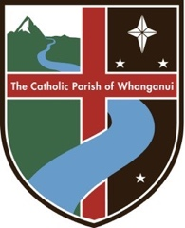

FIRST RECONCILIATION TIMETABLE
Catholic Parish of Whanganui

Session 1
Tuesday 20 February 7.00pm
Meeting with parents only
St Mary’s Church, Guyton St

Session 2
Tuesday 27 February 7.00pm
Meeting with parents and children
St Mary’s Church, Guyton St

Session 3
Tuesday 5 March 7.00pm
Meeting with parents and children
St Mary’s Church, Guyton St

Session 4
Tuesday 19 March 7.00pm
Meeting with parents and children (Including rehearsal and practical stuff)
St Mary’s Church, Guyton St

Thursday 21 March 7.00pm
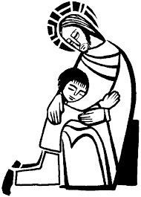
CELEBRATION OF
FIRST RECONCILIATION
St Mary’s Church, Guyton St

